**Table: EMPLOYEE**

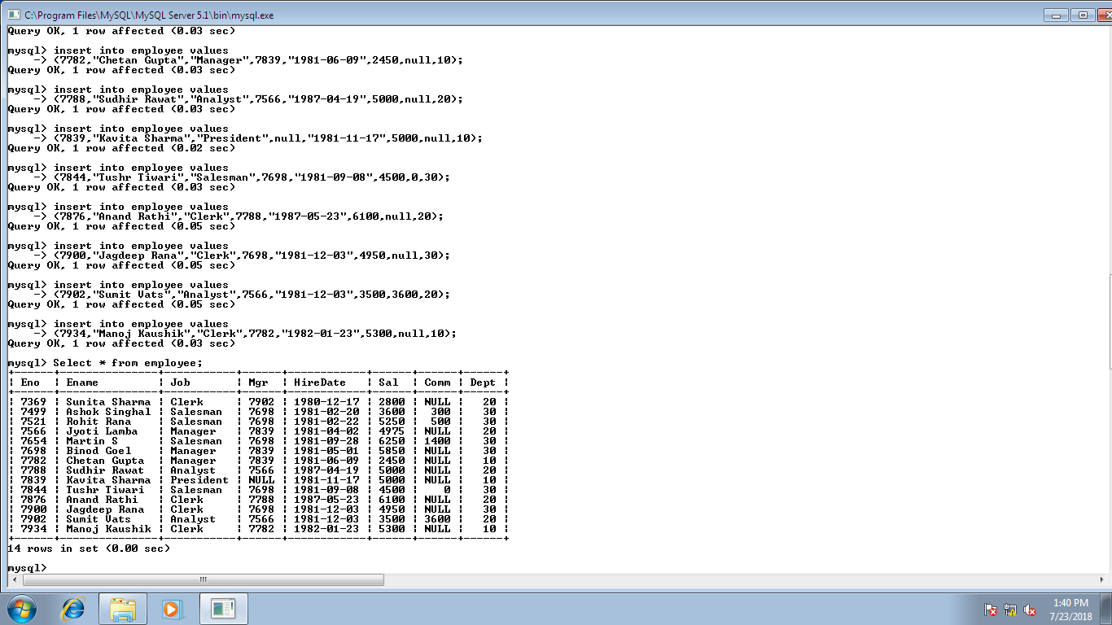

**Queries-**

1. To list all the name and employee number from the above table.
2. To list all the names, hire date and salary of all the employees.
3. To display the employee name and the incremented value of SAL as SAL+300.
4. To list the Employee name and his annual salary(Annual Salary=12*sal+100).
5. Display the Ename and sal where comm. Is NULL.
6. To list the distinct department number from the table.
7. To list unique jobs from the table.
8. To list the salary where salary is less than the commission.
9. To list the salary where salary is between 3000 and 4000.
10. To list the ename which have mgr in 7902, 7566, 7788.
11. To list the ename starting with ‘s’.
12. To list all the employees who do not have a manager.
13. To list all the columns where salary is greater than 4100.
14. To list all the columns in the ascending order of hiredate.
15. To list all the columns in the ascending order of deptno and descending order of salary.
16. To display the employee name and jobs of employees hired between Feb 20, 1981 and May 1,1981.
17. Display the ename and deptno of all employees in department 20 and 30 in alphabetical order by name.
18. To list the name and salary of all employees who earn more than 1200 and are in department 10 or 40.
19. To list name and hiredate of all the employees who are hired in 1981.
20. To list the names and salary of all the employees who earn commission.
21. To list the names of all the employees where the second letter of their name is an ‘a’.
22. To list the names and jobs of all employees who work in department 20 and their manager is 7788.
23. To list the deptno, job and sum of salary group by deptno and job.

**A**

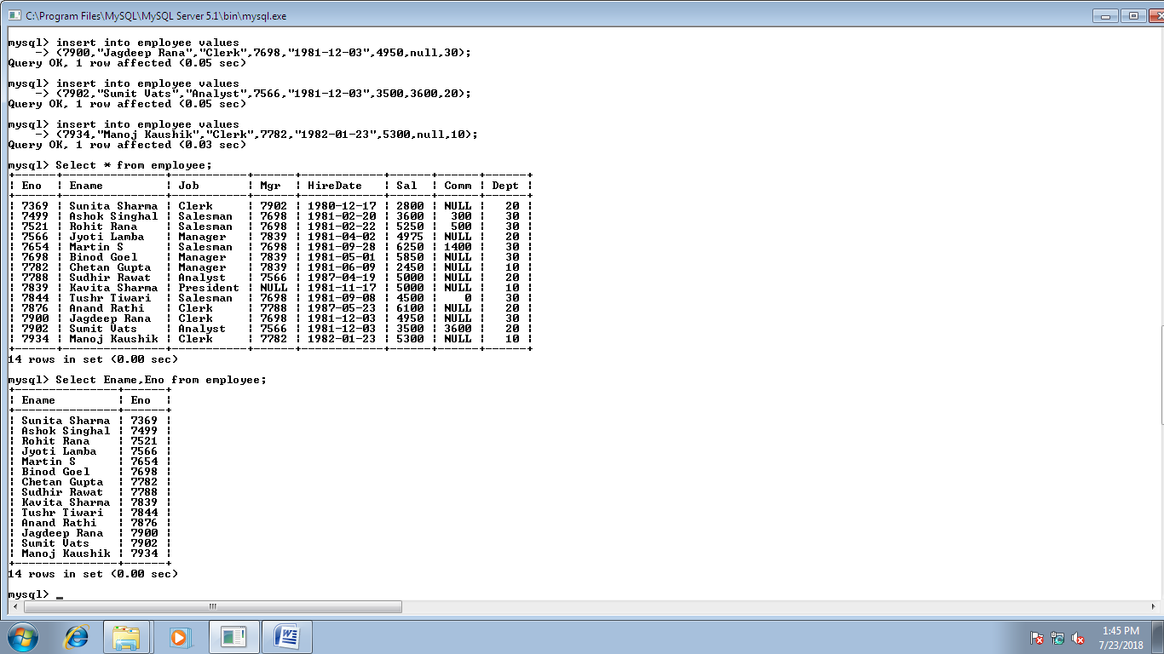

**B**

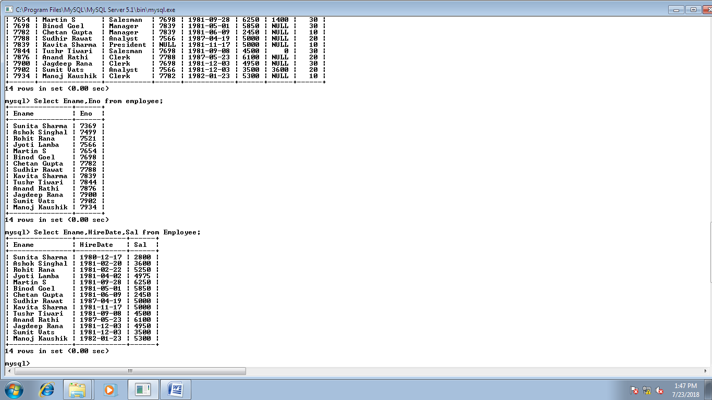

**C**

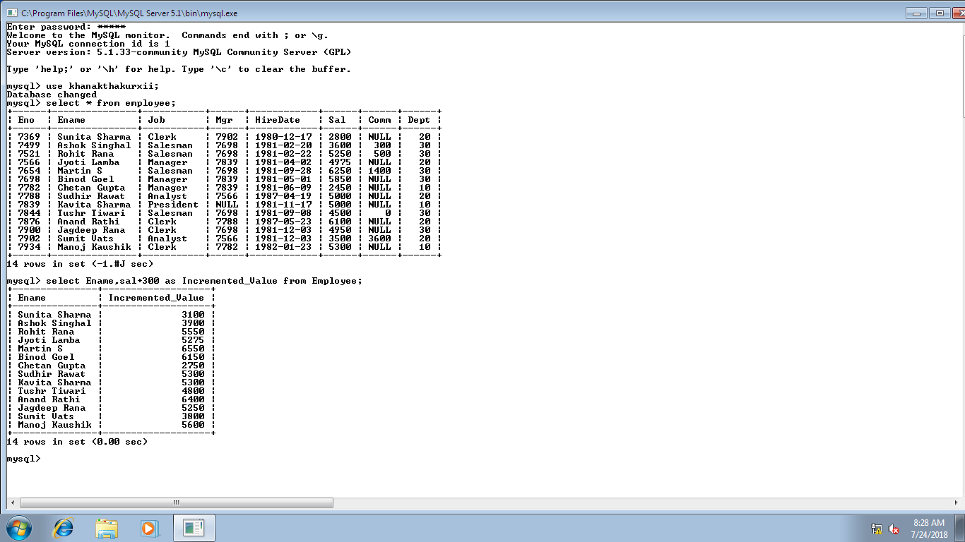

**D**

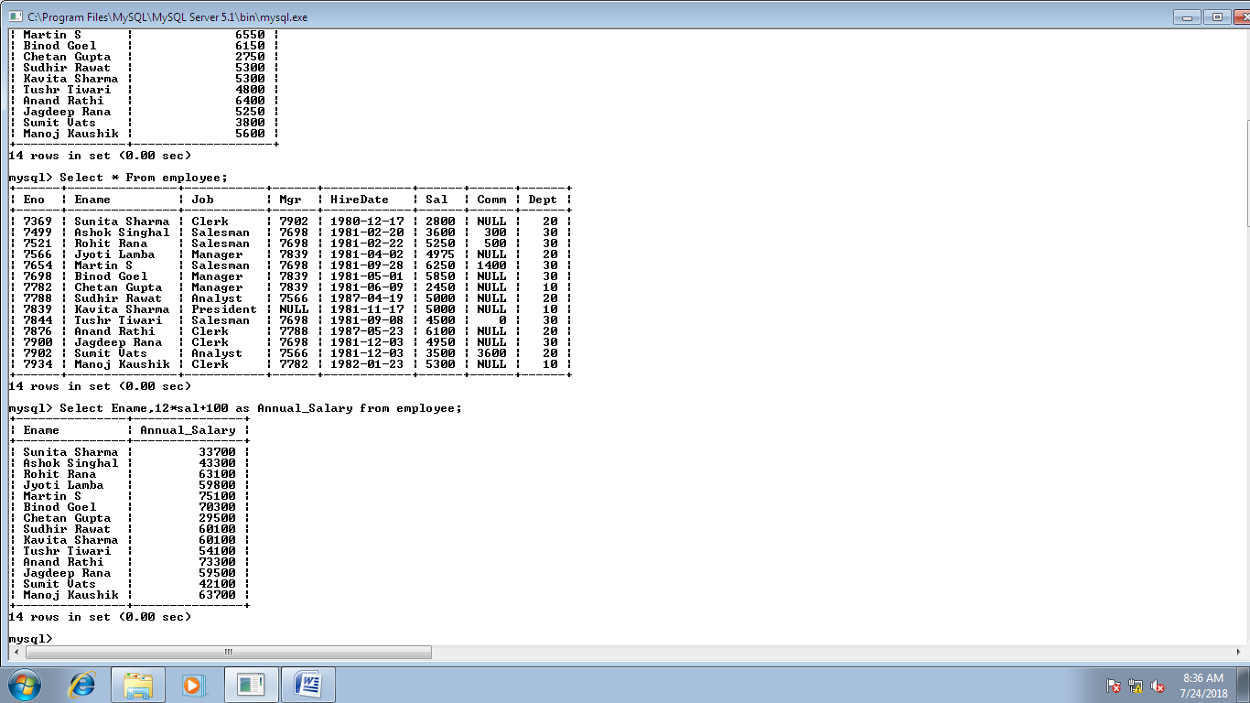

**E**

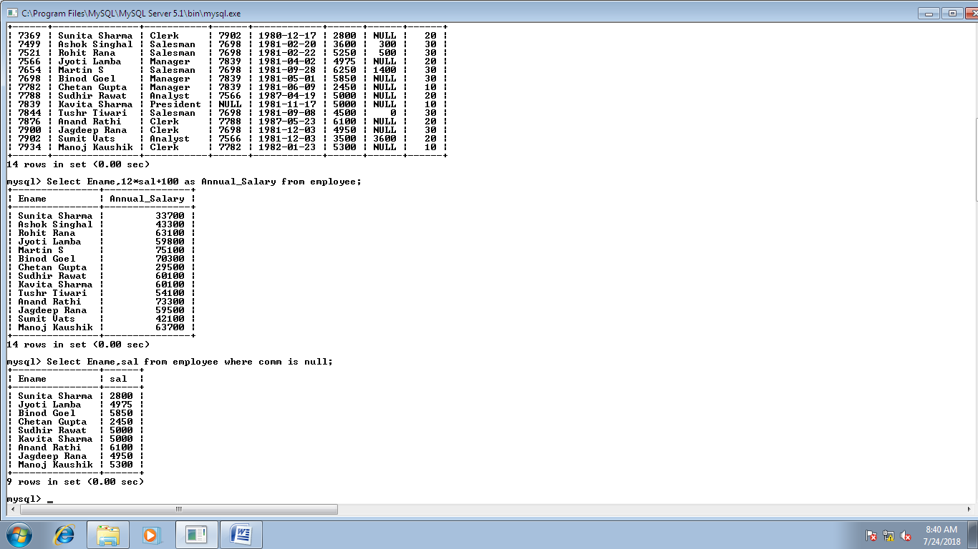

**F**

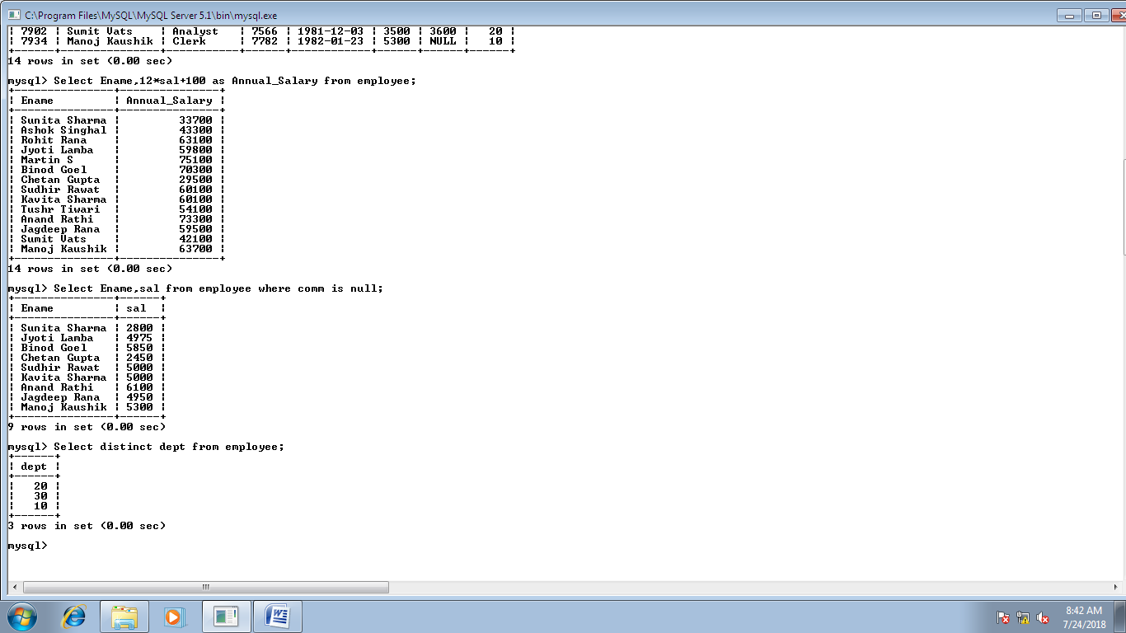

**G**

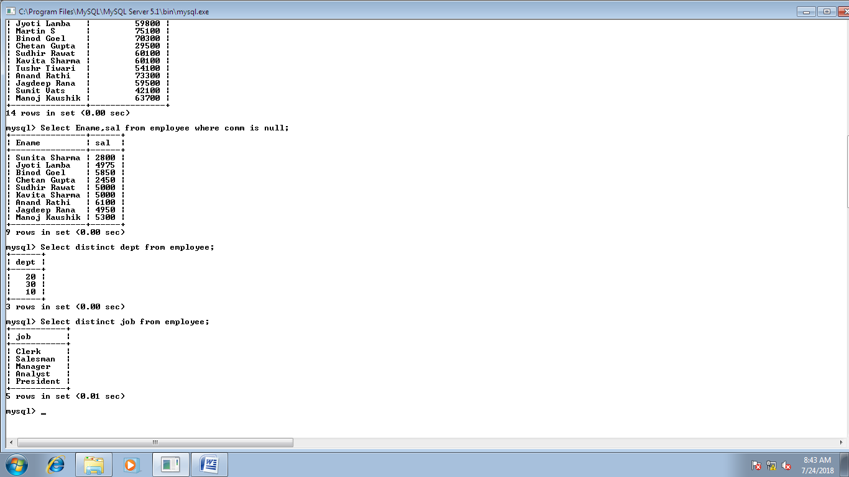

**H**

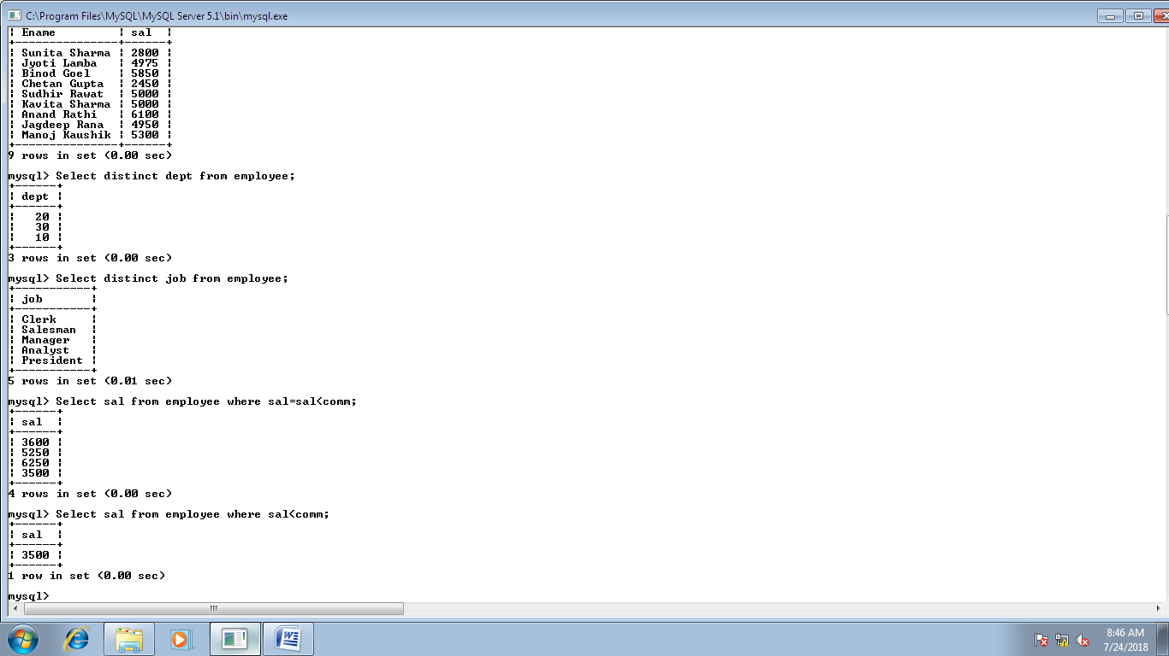

**I**

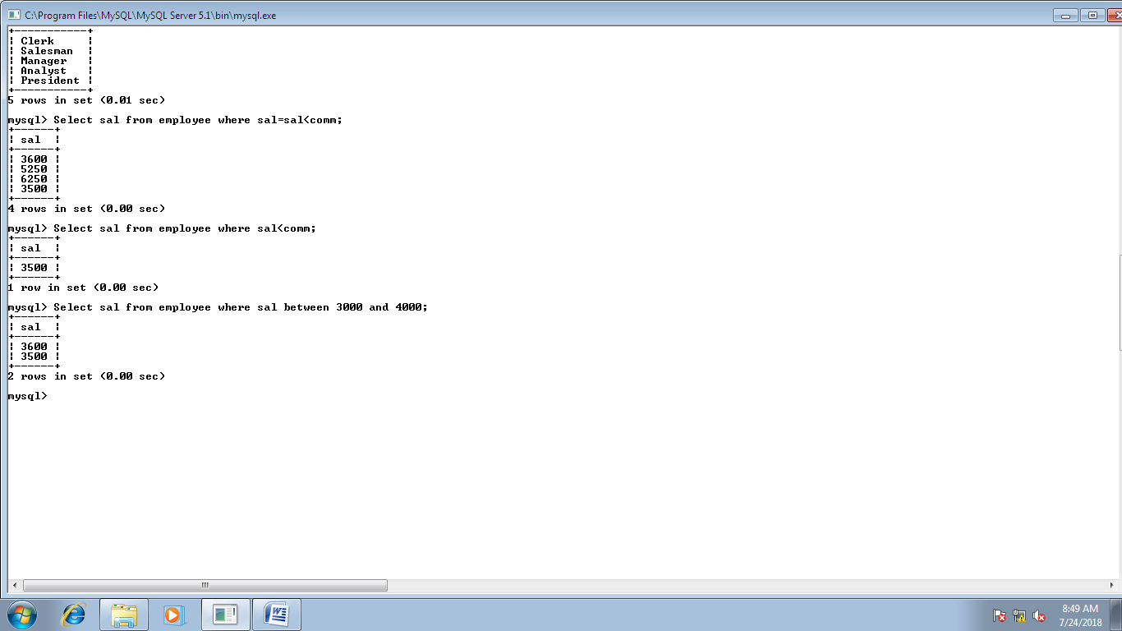

**J**

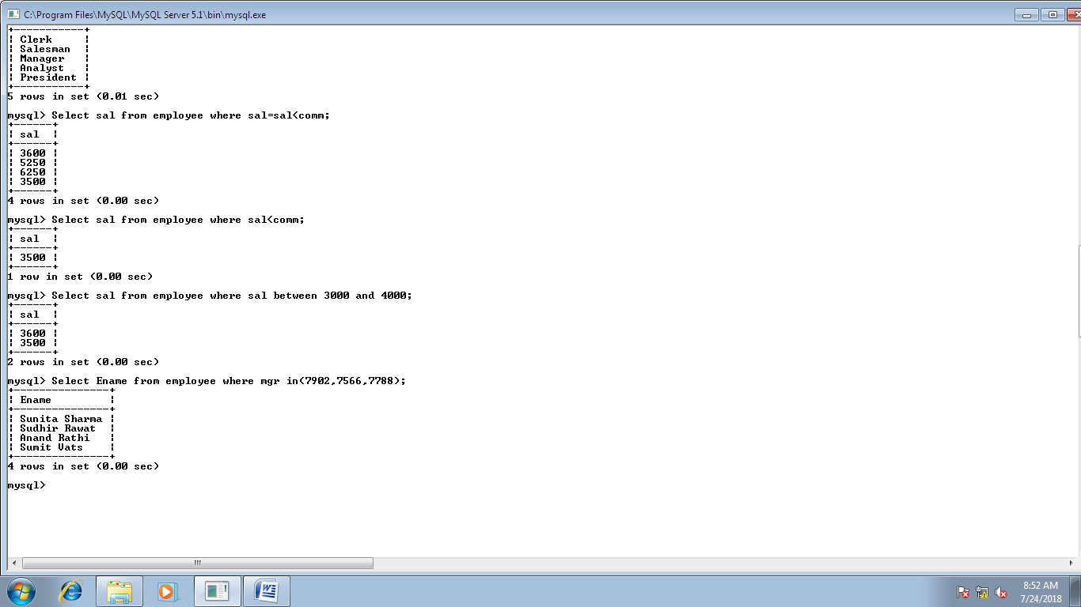

**K**

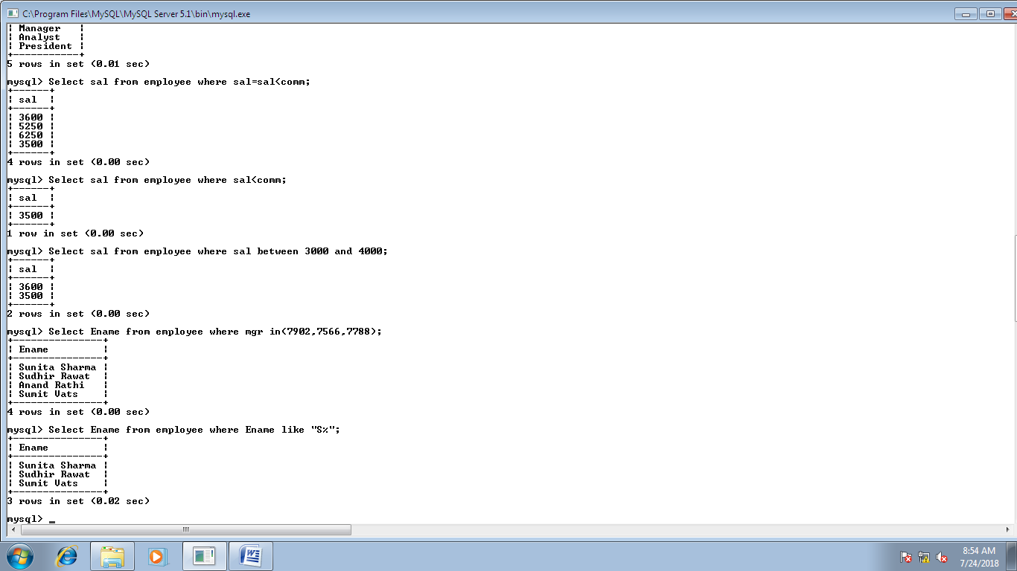

**L**

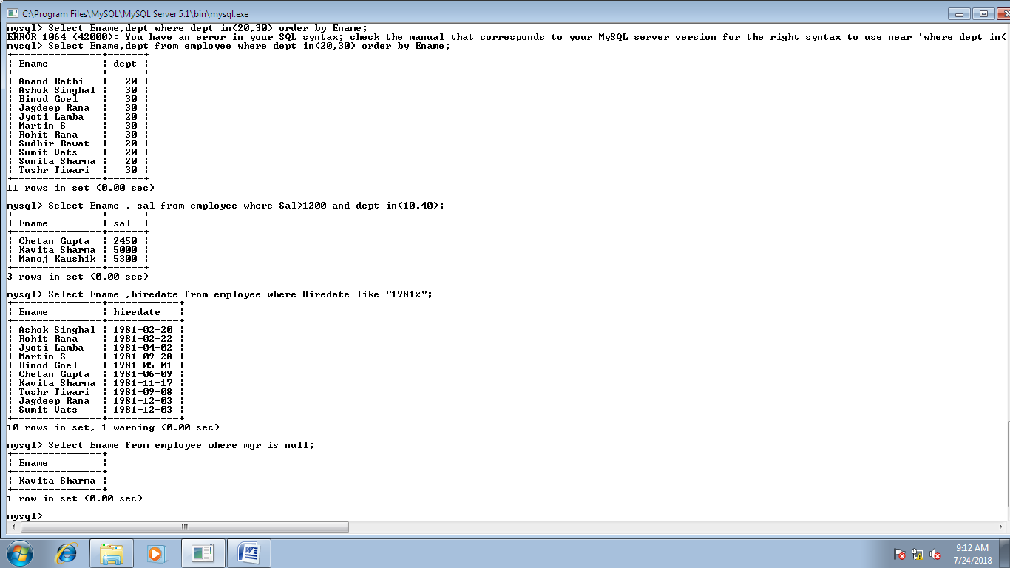

**M**

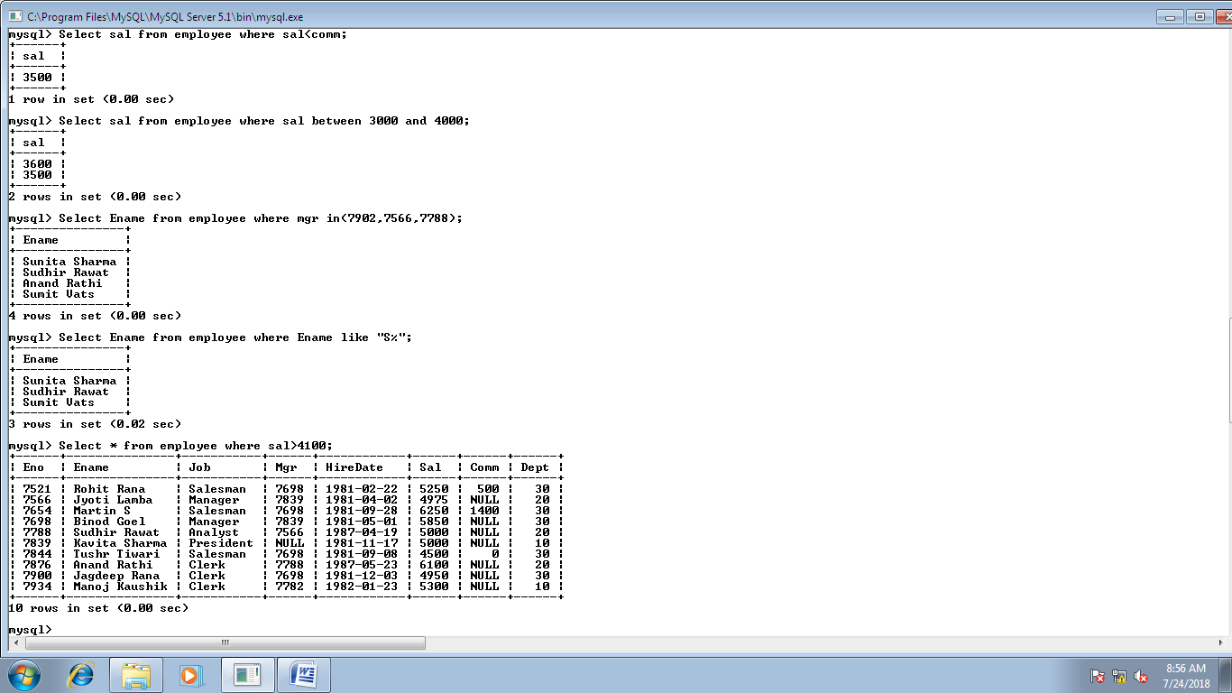

**N**

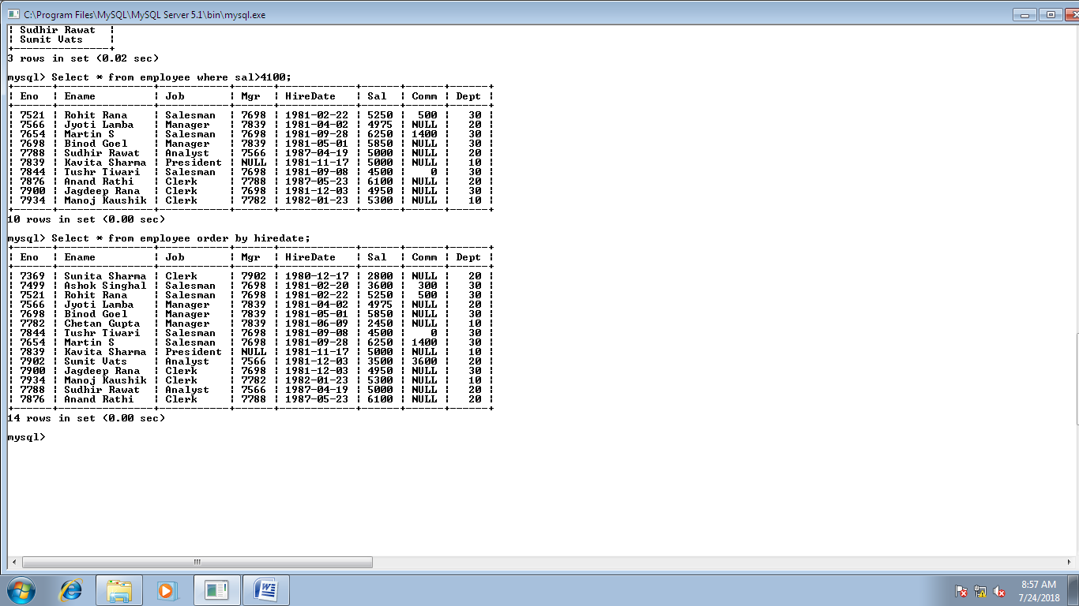

**O**

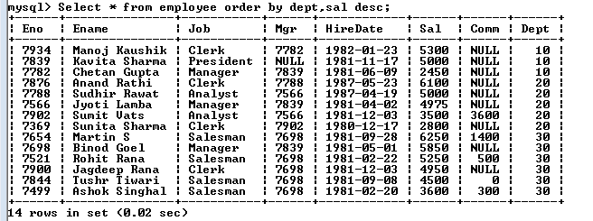

**P**

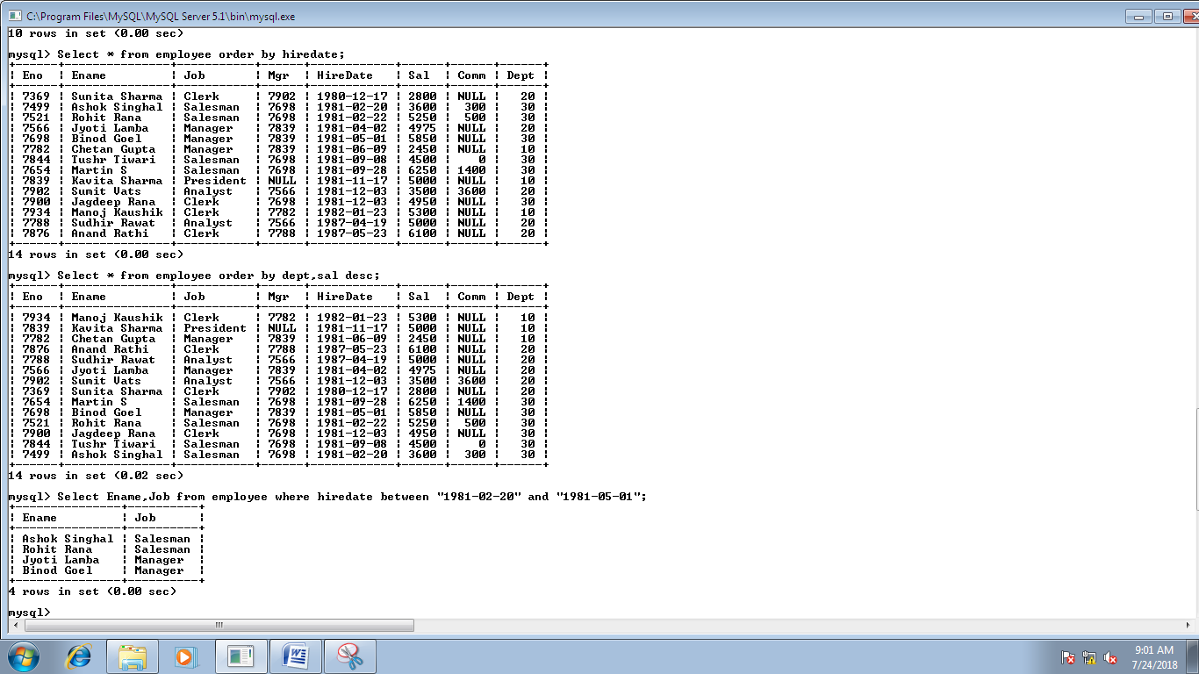

**Q**

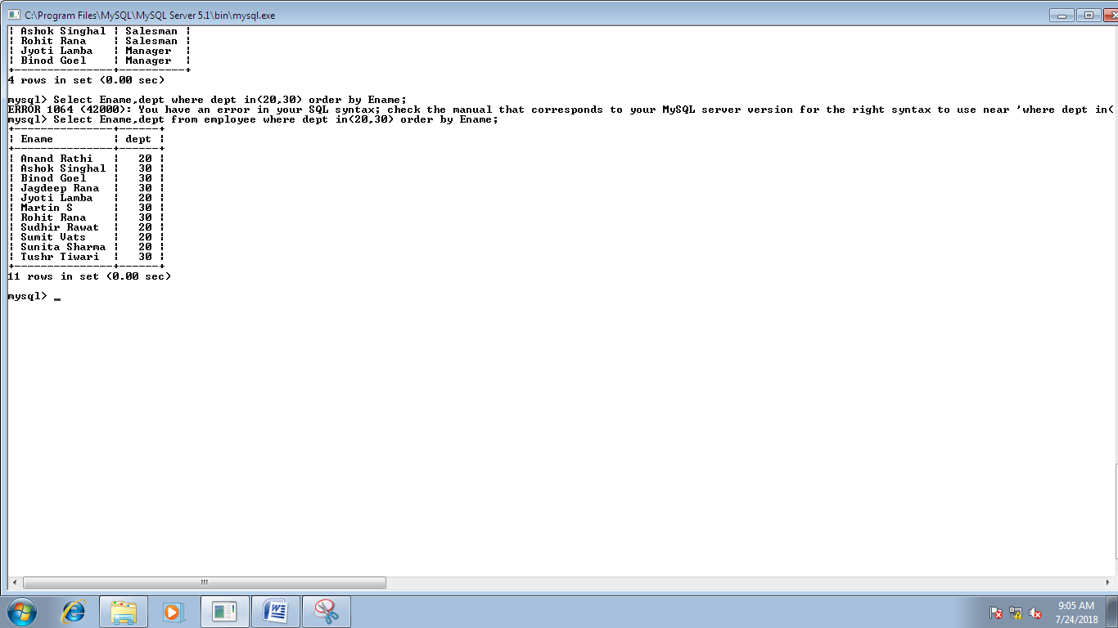

**R**

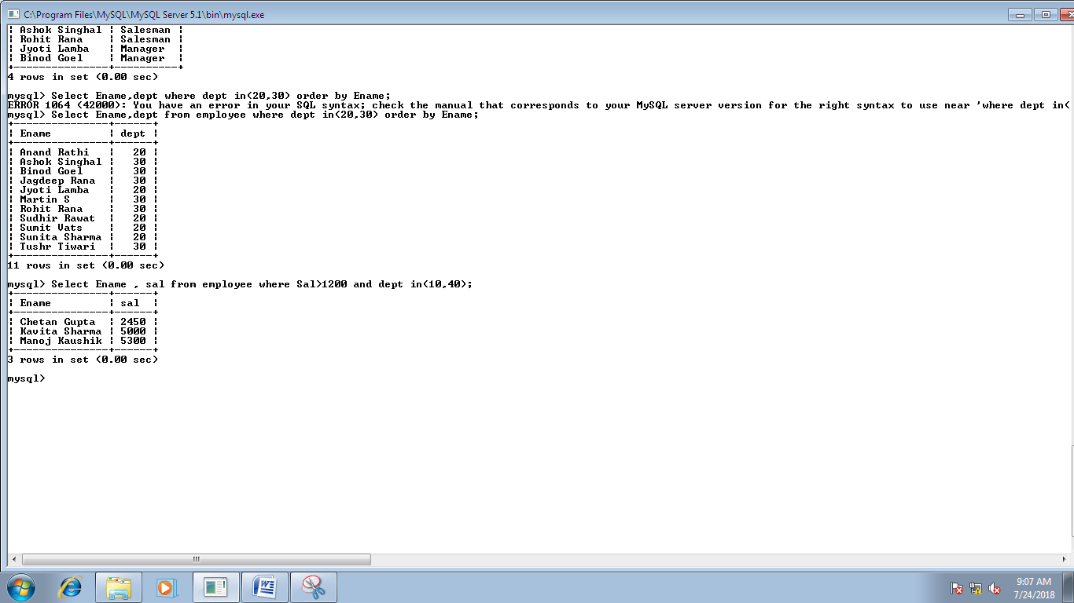

**S**

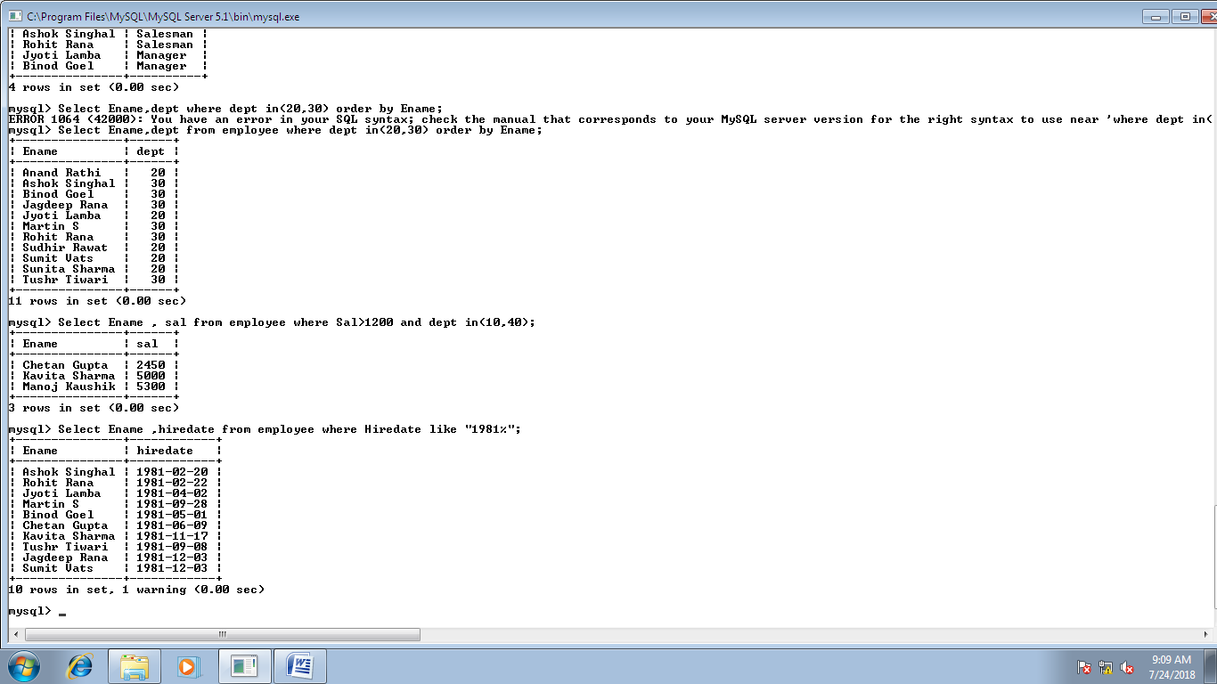

**T**

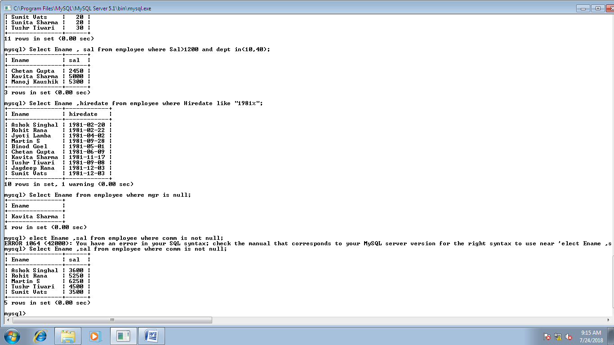

**U**

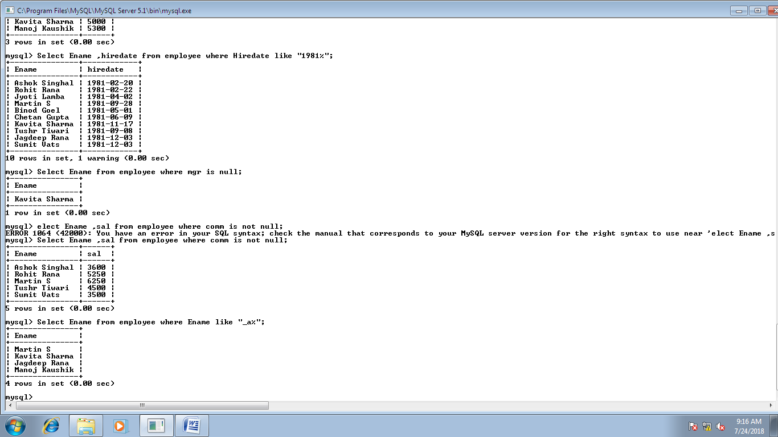

**V**

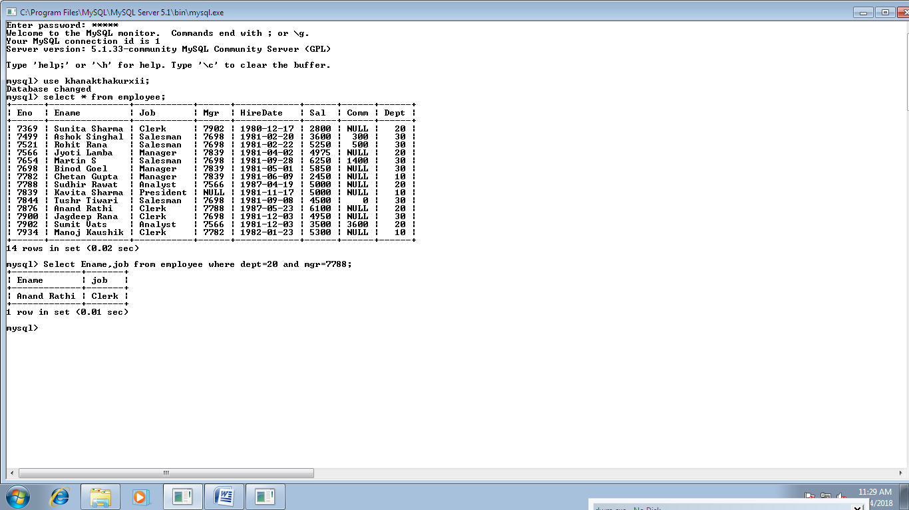

**W**

